In this SLP assignment, you are required to implement the Linear Search algorithm. Your Java program will ask the user to input 10 letters (e.g., e, c, z, x, k, m, o, a, d, f) and your program stores these ten letters into array. Then you will ask the user what letter the user wants to search. If the letter is in the array, your program should return the position of the letter in the array. If the array does not have this letter, a message “Letter is not found” should display.

This assignment is pretty straight forward. I’ve supplied well commented code that fulfills the requirements.

A key point of the Linear Search algorithm is that it’s fast with a runtime of O(n), but could be made faster using hash with number of occurrences and the char value stored in a hash map. I’m looking forward to exploring hash code and hash maps further, as I progress in my studies.

A note: it seems to me that this search algorithm would improve speed if the list were sorted prior to searching it.

Similar char(s)

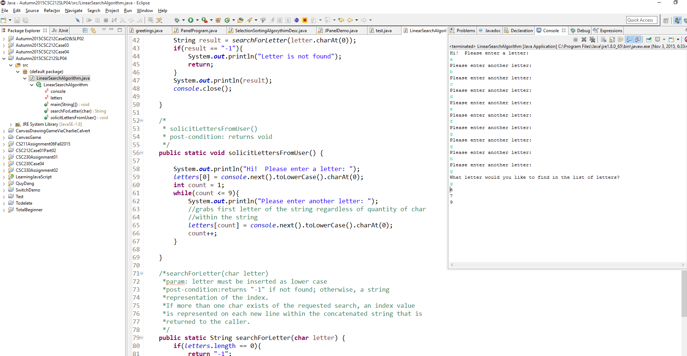

Unique char(s)

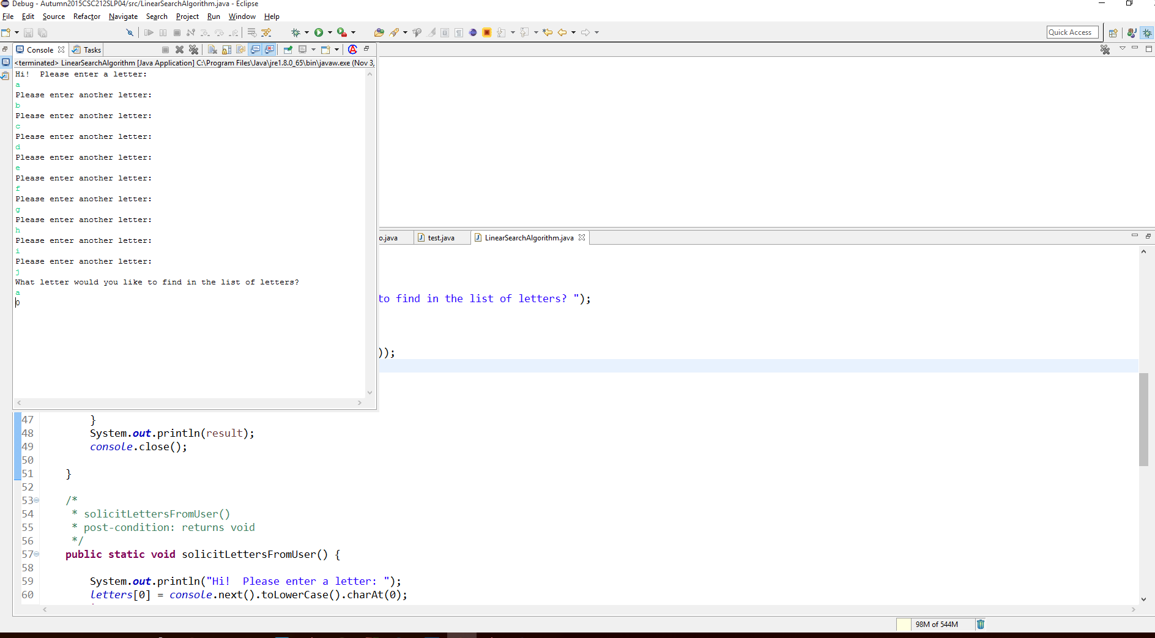

Search for a char that was not inserted into the list

